CS 255 System Design Document Template
Ambren Cavazos

UML Diagrams

UML Use Case Diagram
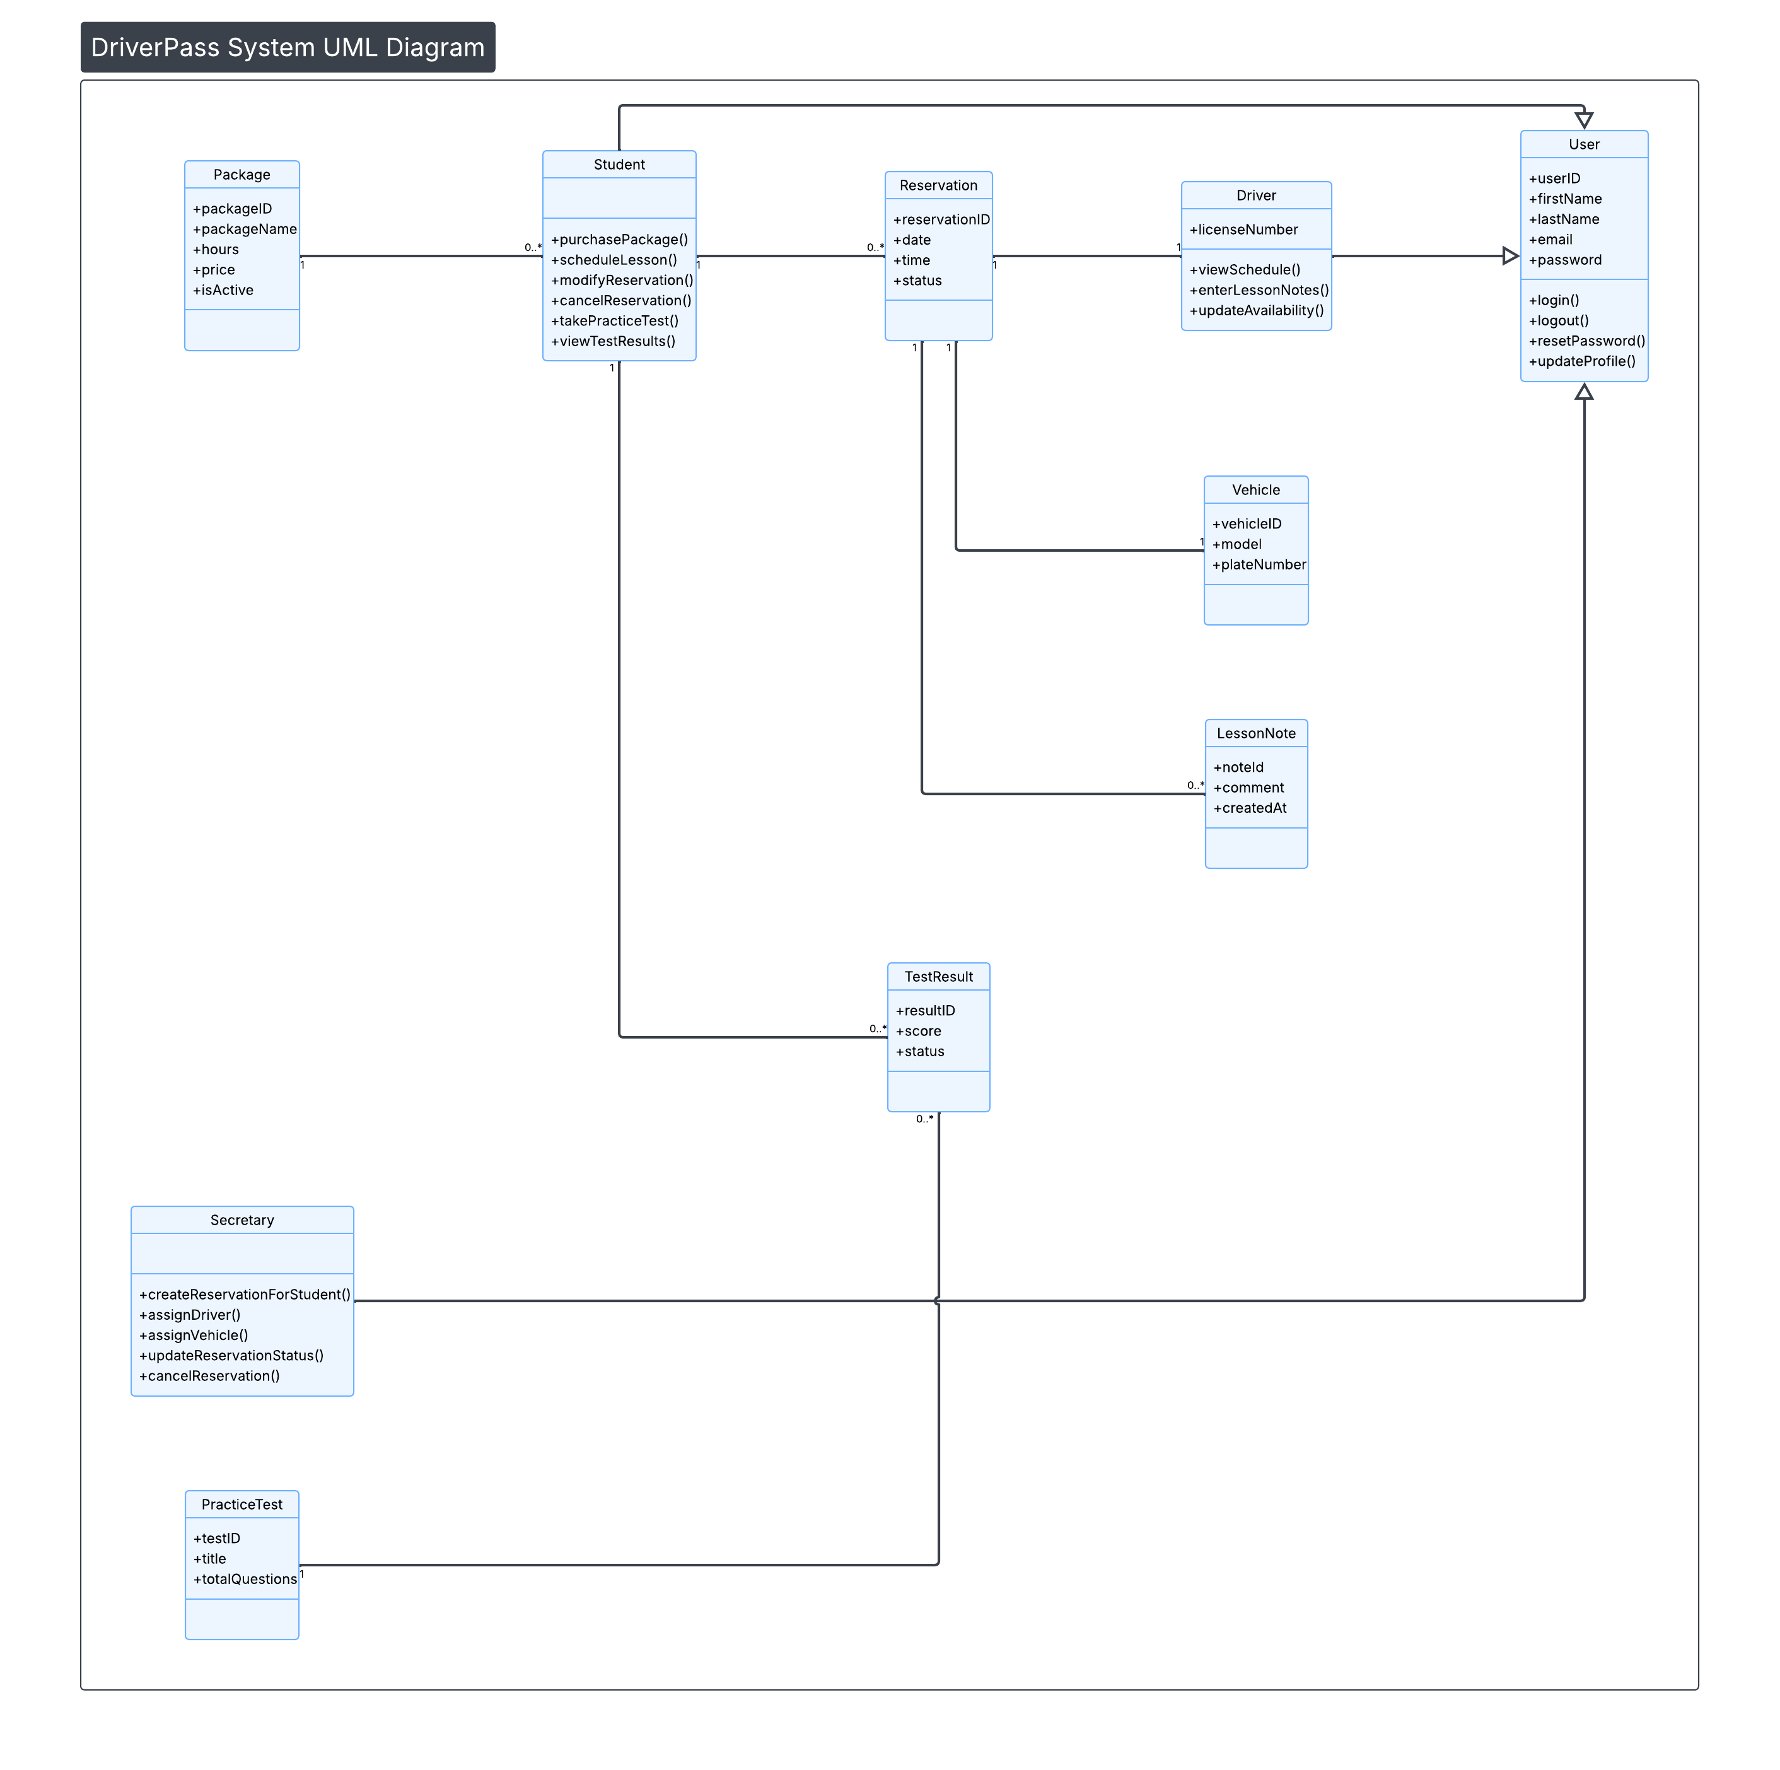
The UML use case diagram illustrates the primary users of the DriverPass system and the major functions available to each user. The main actors include the Student, Driver, Secretary, and the external DMV System. The Student can register an account, log in, purchase training packages, schedule driving lessons, take practice tests, and view test results. The Secretary can create, modify, and cancel reservations, while Drivers can manage their availability and lesson information. The DMV System provides updates that affect practice test content. This diagram ensures that all functional requirements identified in the interview transcript are represented at a high level before development begins.

UML Activity Diagrams
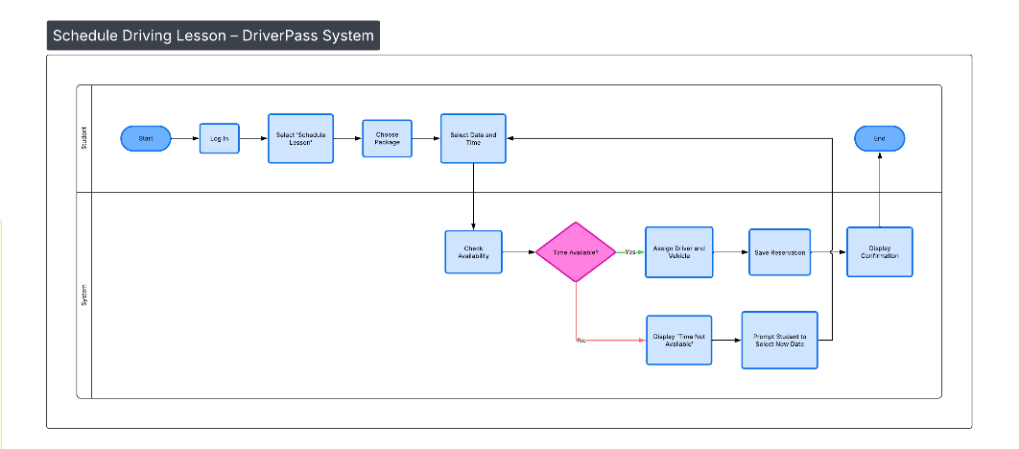
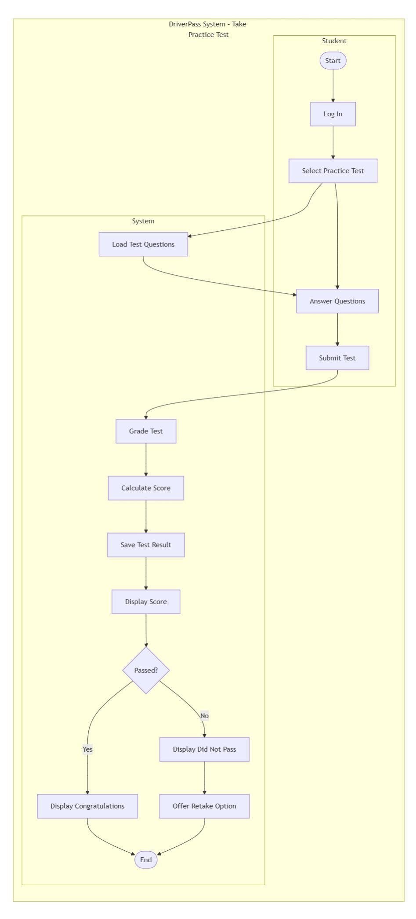
Two UML activity diagrams were created to model the internal workflow of key use cases within the DriverPass system. The first activity diagram models the “Schedule Driving Lesson” process. It includes swimlanes to separate actions performed by the Student from actions performed by the System. The diagram captures decision logic such as checking lesson availability and looping back when a selected time is not available.
The second activity diagram models the “Take Practice Test” use case. This diagram also uses swimlanes to separate Student and System responsibilities. It includes grading logic and a decision node that determines whether the student passed or failed. These activity diagrams ensure that business rules, process flow, and system responses are clearly defined before implementation.

UML Sequence Diagram
The UML sequence diagram models the interaction between system components during the selected use case. For example, in the “Schedule Driving Lesson” use case, the diagram shows how the Student interacts with the system interface, how the system checks availability, creates a reservation, assigns a driver and vehicle, and confirms the reservation. The sequence diagram clarifies the order in which messages are exchanged between objects and ensures proper coordination between system components. This helps prevent logical errors during development.

UML Class Diagram
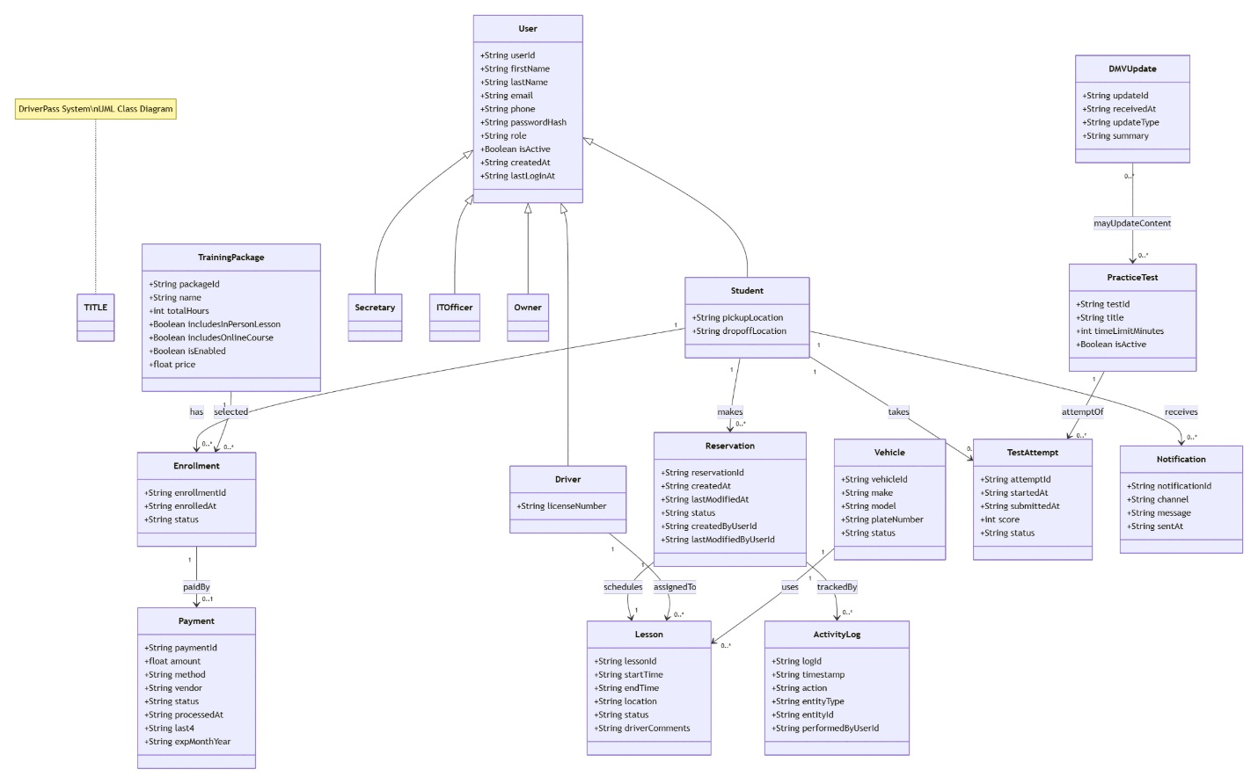
The UML class diagram defines the static structure of the DriverPass system. Core classes include User, Student, Driver, Secretary, Package, Reservation, Vehicle, PracticeTests, Test results, and LessonNotes. Inheritance is used to represent shared attributes among different user types. Associations and multiplicity values clarify How many objects can relate to one another, such as a student having multiple Reservations or TestResults. This diagram supports object-oriented Implementation and database design by clearly defining system entities and their relationship.

Technical Requirements
The DriverPass system will be developed as a web-based application accessible through modern web browsers. The system must support both desktop and mobile devices to allow students to schedule lessons and take practice tests from various locations. A cloud-based hosting environment will be used to ensure scalability, reliability, and automated data backups.
The system will require a secure web server, a relational database management system to store user accounts, reservations, packages, and test results, and role-based access control to restrict system functionality based on user type. User authentication must include encrypted password storage to ensure security. The system must also support integration with the external DMV system to receive updates to testing rules and materials.
The development environment may include common web technologies such as HTML, CSS, JavaScript, and a server-side programming language such as Java, Python, or C#. Cloud infrastructure services such as AWS, Microsoft Azure, or Google Cloud may be used to host the application and manage system resources. Regular system monitoring and scheduled backups will be required to maintain reliability and data protection.

